**Craft catchy newsletter copy**

Writing marketing emails is something that takes a lot of practice and patience. You won’t learn every skill you need to be a professional writer in this program, but you can use these tips to ensure you’re setting yourself up for success when crafting emails.

**Write to add value**

As a digital marketer, your goal is to convince people to open, read, and click on the links in your marketing emails. To achieve this goal, write content they will want to engage with. Every email you send should add value to the subscriber in some way. Whether you’re introducing them to new products or services, making them laugh, or teaching them something new, each element in your emails needs to be thoughtful and intentional.

**Subject line**

A **subject line** is the first text recipients see after your name when an email reaches their inbox.The subject line is your subscribers’ first impression of the email, so it’s important to make it compelling.

When you write your subject line:

* **Keep it brief.** Your subject line should be about 6-10 words total. If it’s too long, it may be cut off from being viewed entirely by your subscribers.
* **Pique readers’ curiosity.** Write a subject line that makes readers interested in the content of your email. If you’re sending emails to a list of people who added items to their cart but abandoned it at some point during the checkout process, you might include a subject line like: “These items are too good to leave in your cart.”
* **If you’re offering something, be clear about it.** Whether it’s an experience, a new piece of information, a discount, or something else, make sure subscribers know there is a benefit to opening your email.
* **Consider personalizing it**. If you use an email marketing tool, you will have the capability to personalize emails by using first names. This is a great way for subscribers to feel like you’re talking to them specifically. Depending on which tool you use, the way you do this will be a little bit different, so read up on your specific tool.

**Preview text**

Preview text is another important aspect of your marketing emails. **Preview text** is next to an email’s subject line in the inbox and gives extra insight into what’s inside the email. It may be secondary to your subject line, but it’s still visible from readers’ inboxes; they see it before they click into your email. Your preview text tells readers exactly what to expect in opening the email.

When you write preview text:

* Make sure to include the most important piece of information from your email. What is the main point you are attempting to communicate? That should be your preview text.
* Make sure it aligns with what your subject line says. The subject line and preview text should work together to entice subscribers to open the email.
* Sometimes, you may want to maintain a sense of mystery. Writing preview text that teases the content can be an effective way to get readers to open an email. Preview text  like: “The recipe you didn’t know you needed…” might be an effective way to make your subscribers curious about the contents of your email. Before you do this, think about your goals and objectives and whether this makes sense for your brand.
* Keep it between 35-50 characters. Your preview text should be brief enough that your subscribers can read it quickly.

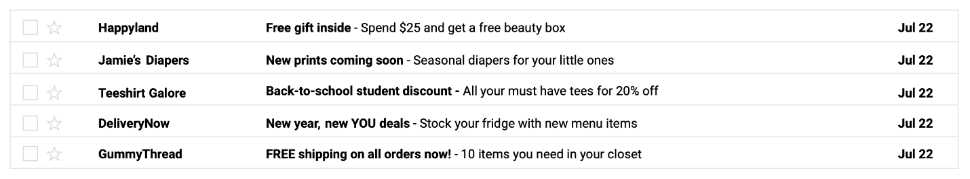

**Body**

The email body is where most of your content will be. You can test out different approaches when it comes to your email body, because what is right for other companies may not be right for you.

When writing your body:

* Maintain a second person perspective. This means you will always want to write your emails as though you are speaking to your subscribers. You want the email to seem personal and specifically crafted for your readers. Second person—also referred to as “you” language—helps create a sense that the writer is talking directly to you, the reader. This makes readers feel engaged and involved. A phrase like “Here’s a discount for you,” is more powerful than “Here’s a discount for our readers.”
* When possible, break up blocks of text with white space. You don’t want your email to seem overwhelming to the reader, so be brief and include visual breaks in between your text.
* Include a compelling call to action. Your readers are more likely to do what you ask of them if you ask them clearly. If you want them to buy an item, encourage them to do exactly that. Sometimes, emails will have several calls to action—especially in newsletters, where several products, services, or links are likely being shared.

**Key takeaways**

Writing compelling content is a huge part of email marketing, and it takes time to get it right. If you follow the tips provided here, you’ll have a much better chance at growing your open rates. When you craft a subject line, preview text, and email body, make sure to be thoughtful and intentional. Also, feel free to test different email copy to see what your audience responds to best.